Voltage regulator circuit
Cheng Jiang
South China University of technology (SCUT), College of Integrated circuit
202264680374
ARTICLE INFO ABSTRACT
In this experiment, the ratio of output voltage to input voltage change, ripple rejection ratio, output resistance and other parameters are calculated by measuring the input and output voltage, input and output ripple voltage peak-to-peak, open-circuit voltage and load voltage of the voltage regulator circuit. This is used to determine the stability of the voltage regulator circuit.
Submission Date:
November 6, 2023
Keywords:
Voltage regulator circuit
Ripple rejection ratio
1. Introduction
The so-called voltage stabilizing circuit refers to a circuit that can maintain a constant output voltage when the input voltage, load, ambient temperature, circuit parameters, etc. change. Voltage stabilizing circuit is a commonly used circuit in modern electronic technology. It is also an important component to ensure the normal and stable operation of electronic equipment. The voltage stabilizing circuit usually includes four parts: adjustment component, reference voltage circuit, sampling circuit and comparison amplifier circuit.
2. Objectives
1. Comprehend the composition and principle of voltage stabilizing circuits.
2. Implement the construction and debugging of voltage stabilizing circuits.
3. Understand and calculate relevant indicators of voltage stabilizing circuits.
3. Principle
3.1 Circuit composition
When the voltage of the power grid changes or the output load changes, the circuit that can keep the output voltage unchanged is called a voltage stabilizing circuit. DC regulated power supply is one of the most basic and commonly used instruments in electronic equipment. As an energy source, it can ensure the normal operation of electronic devices.
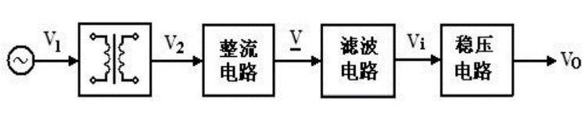
Figure 3.1-1 Block diagram of DC voltage stabilizing circuit
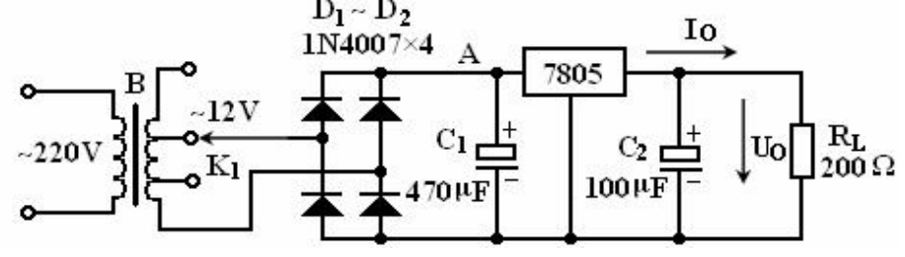
Figure 3.1-2 voltage stabilizing circuit with a fixed output of 5Vcircuit
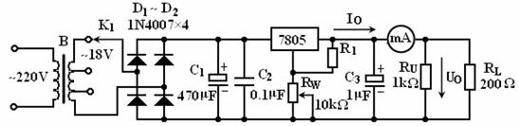
Figure 3.1-3 Adjustable output voltage stabilizing
DC stabilized power supply generally consists of three parts: rectifier circuit, filter circuit and voltage stabilizing circuit, as shown in Figure 3.1-1. This experiment mainly discusses the DC voltage stabilizing circuit composed of linear integrated voltage stabilizing component 7805.
Figure 3.1-2 is a voltage stabilizing circuit with a fixed output of 5V composed of bridge rectifier, capacitor filtering and 7805 linear voltage stabilizing integrated block. Figure 3.1-3 is a bridge rectifier, capacitor filtering and 7805 linear stabilizing integrated block. It is an adjustable output voltage stabilizing circuit composed of voltage integrated blocks. The functions of each capacitor in the circuit are: C₁ is the filter capacitor, and the empirical formula between this capacitance and the load current I₀ is usually C₁ = (1500~2000)·I₀ (μF); C₂ is to suppress the self-oscillation of the voltage regulator; C₃ is the high-frequency noise bypass capacitor.
3.2 Main index parameters of voltage stabilizing circuit
Output voltage and its adjustable range: For adjustable regulated power supplies, the adjustable range of output voltage reflects the adaptability of the power supply's output application range.
Voltage stabilizing coefficient Sr: refers to the ratio of the relative change in output voltage U_{O} to the relative change in input voltage U_{I} of a DC voltage stabilizing power supply when the load current and ambient temperature remain constant, expressed as:
Ripple suppression ratio S_{SRPP}: The voltage stabilizing circuit cannot completely eliminate the AC component, and the introduction of ripple suppression ratio describes the performance of the voltage stabilizing circuit. Defined as 20 times the logarithmic value of the ratio of input ripple voltage peak to peak and output ripple voltage peak to peak:
The larger the ripple suppression ratio, the stronger the ability of the voltage stabilizing circuit to eliminate AC components.
Output resistance R_{O}: defined as the ratio of the change in output voltage to the change in output current when there is no change in input voltage and ambient temperature. In experimental measurements, the output resistance is usually regarded as an internal resistance similar to that of a power supply. By measuring the open-circuit output voltage U_{O} and the voltage U_{O} on the load R_{L}, it can be substituted into the formula:
4.Equipment
AC power supply, digital multimeter, capacitor (0.1μF,1μF,470μF), resistance (100Ω,200 Ω,1KΩ), potentiometer(10KΩ), diode, three terminal voltage regulator (7805), dual trace oscilloscope, 9-hole plug-in board, input power supply, handheld multimeter, connecting line, etc.
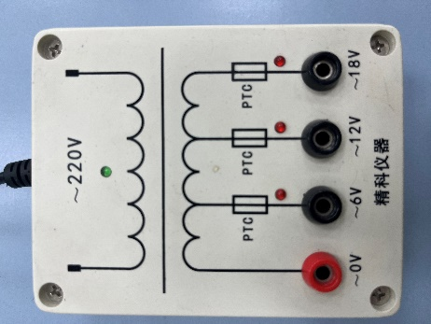 | 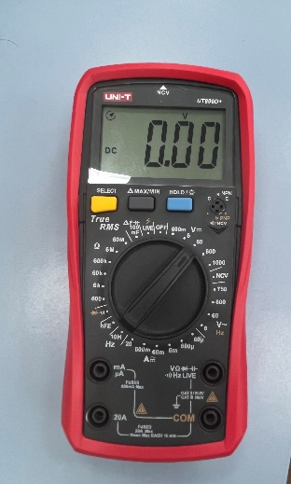
Figure 4.1-1 Input power supply | Figure 4.1-2 Handheld multimeter
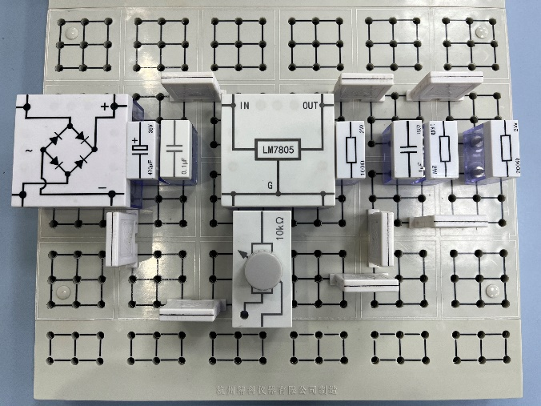 | 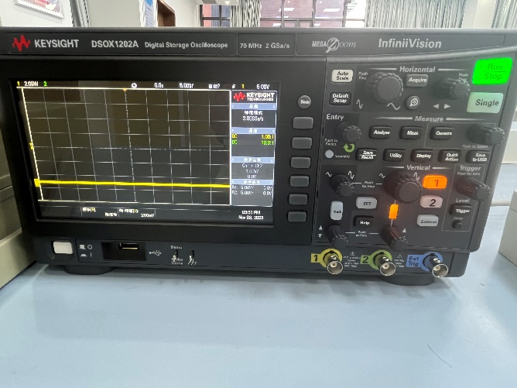
Figure 4.1-3 9-Hole plug-in board and experimental circuit | Figure 4.1-4 Dual trace oscilloscope
5.Procedures
5.1 DC voltage regulator circuit composed of 7805:
① Connect the circuit according to Figure 5.1-1, disconnect the circuit at point after connection, measure and record the waveform of U_{I} (that is, the waveform of U_{A}), and then switch on the circuit behind point A, observe the waveform of U_{O}, if any oscillation should be eliminated. Adjust the R_{W}, if the output voltage changes, the circuit works normally.

Figure 5.1-1 Adjustable output voltage stabilizing
② Measuring the output range of the stabilized power supply: Adjust the R_{W}, monitor the output voltage U_{O} waveform with oscilloscope, respectively measure the maximum and minimum output voltage of the regulator circuit, and the corresponding U_{I} value. Measure the reference voltage of the regulator block (i.e. the voltage at both ends of the 100Ω resistor).
③ Observe ripple voltage: Adjust R_{W} to U_{O} = 5V, observe the waveform of the input voltage Ui of the voltage regulator circuit with an oscilloscope, and record the size of the ripple voltage, and then observe the ripple of the output voltage U_{O}, and compare the two.
④ Measure the output resistance R_{O} of the stabilized power supply: disconnect R_{L}, and measure the voltage at both ends of R_{L} with a multimeter, denoting it as U_{O}’. Then access R_{L}, measure the corresponding output voltage, recorded as U_{O}, use the following formula to calculate R_{O}:
6. Original Data
The recorded original data is shown in Table 6.1-1 and Table 6.1-2:
Table 6.1-1 Peak-to-peak measurement of input and output voltages and input and output ripple voltages
Input voltage U_{I} | Output voltage U_{O} | Input ripple voltage peak to peak U_{OPP} | Output ripple voltage  peak to peak U_{IPP}
14.87V | 5.07V | 1.73V | 60mV

Table 6.1-2 Measurement of open-circuit voltage and load voltage
 | The first time | The second time
Open-circuit voltage U_{O}’ | 5.065V | 5.068V
Load voltage U_{O} | 5.063V | 5.066V
7. Analysis
7.1 Calculate the voltage stabilization coefficient
From the data in Table 6.1-1 and Table 6.1-2, we take relative variation of output voltage $∆$U_{I} and relative variation of input voltage $∆$U_{O} as half of U_{IPP} and U_{OPP}, respectively, and then we bring these data into Equation 1 (Output voltage U_{O} = 5.07V, Relative variation of input voltage $∆$U_{I}= 0.865V, Input voltage U_{I}= 14.87V, Relative variation of output voltage $∆$U_{O} = 30mv):
By calculation, we can know that S_{r} = 0.1017.
7.2 Calculate the ripple suppression coefficient
From the data in Table 6.1-1, we bring these data into Equation 2:
By calculation, we can know that S_{SRPP} = 29.1979.
7.3 Calculate the output resistance (R_{L} = 200Ω)
From the data in Table 6.1-2, we bring these data into Equation 3:
By calculation: we can know that R_{O1} = 0.079Ω, R_{O2} = 0.079Ω. By averaging the two measurements, we get R_{O} = 0.079Ω.
8. Conclusion
For the voltage regulator circuit in this experiment, we measure the ratio of the relative change of the output voltage to the relative change of the input voltage S_{r} is 0.1017, the ripple rejection ratio S_{SRPP} is 29.179, and the output resistance R_{O} is 0.079Ω, indicating that the voltage regulator circuit is stable.
9. Appendix
